DEAN A. PHILLIPPI
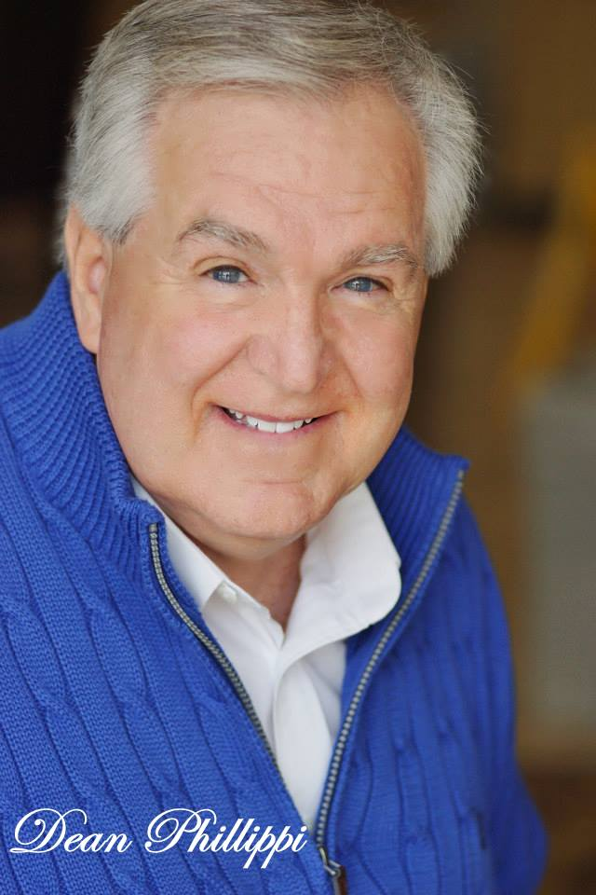

Phone: (904)401-0153 Email: Dean9579@comcast.net
Website: https://www.facebook.com/DeanPhillippiSR.Actor/

IMDBPro Page: https://pro-labs.imdb.com/name/nm6157578
Christian Film Website: http://www.christianfilmdatabase.com/profile/dean-phillippi/
Height: 6’1”
Weight: 220
Eyes: Blue
Hair: Salt & Pepper

FILM
- THE ANSWER  - MIXED NUTS  - TATTLETALE CORPSE  - KANDY KANE KILLER  - A SOLDIER’S GIFT (Pre—Production)  - NEVER GO BACK  - DEFYING DEMONS (Pre-Production)  - PLEASANT VALLEY (Pre-Production)  - THE CHRISTMAS BEACON  (Pre-Production)  - DANCER (Pre-Production)  - LOSING FAITH  - LOVE WAITS TRUE  - THE RACE  - GREEN FROM THE GRAVE  - CHRYSALIS “SIZZLE”  - CHRISTMAS WEDDING BABY  - IMPLODE / HAVOC | Judge Beckon - Supporting  Jack Bridgers – Supporting  FBI Agent Andrews - Supporting  Howard Huntley TV News Anchor - Supporting  Colonel Forrest - Supporting  Stan Motuski – Supporting  Priest - Supporting  Doctor Able - Supporting  Pastor Adrien McKay – Supporting  Pastor Harold Smithton - Supporting  Pastor Robert Cobb – Supporting  John – Lead  Mr. Wells - Supporting  Professor Wright - Nuclear Lab Professor- Supporting  Military Captain - Supporting  Wedding Party - Featured  Sarge - Military Sergeant - Lead | David Rivers – Director / Aaron Knee - Producer  Scott Christenson – Amazon River Productions  Ray and Migdalia Etheridge - Director/Producer  Bladeworld Films – Adrian Blade Director/Producer  Lum Pictures, LTD - Kent Taylor – Director / Producer  Durden Godfrey – Director / Producer  Brian Wyatt – Director / Producer  Chris Robinson – Director/Producer  Archangel Global Productions  Tandem Media - James Radcliff – Director – Lanny Smith Producer  Mustard Tree Productions - Darren Cole Butcher Director  Reel Insight Productions – Mike Heath - Director  Reel Insight Productions – Mike Heath - Director  Tandem Media - James Radcliff - Director  Roy Garton – Director - FDMC Productions  Tandem Media - James Radcliff - Director  Cultivated Films LLC - Director: Kiara C. Jones  Moving Pictures Film & Music Production  – Director: Ralph S. Anders
- SNUG | Policeman - Featured | Iron Rock Studios – Director: Ithiell Yzrael
- SPONGEBOB II | Street Merchant - Featured | Marty Sui Casting
- JUSTICE COALITION  - TASTINGS | Judge - Supporting  Winery Store Manager - Featured | Name Sake Pictures and Justice Coalition – Director: Mauricio Belgrano  Wisdom Age Productions - Director: Neil Watson
- WITH BLOODSHOT EYES | U.S. President - Lead | Richard Kodai - Director
- WAITING FOR LOLA | Bus Station Merchant - Featured | L. Gustavo Cooper – Director
- SUNNY ACRES | Poker Card Dealer - Lead | Terry Knaul – Director – FSCJ College
- THE STORY  - FLOWERS WHICH BLOOM  - THE DEBT  - 22  - GRACE OF THE FATHER  - CHRISTINE  - BIRTH OF A NATION (NAT TURNER STORY)  - GROUND ZERO  - TO PLANT A SEED | College Professor - Lead  Museum Patron - Featured  Tourist - Featured  Government Official - Supporting  Train Passenger - Featured  Restaurant Patron - Featured  Court Official - Featured  911 Survivor - Featured  Jack White - Lead | Robert Kleszczynski – Director – University of  Florida College  Samad Banks & Kim Murray – Director/Producer - Flicker Studios,  Mahmoud Shoolizadeh - Director  Vollmer Video & Photography – Director: Trey Vollmer  Lazarus Productions – Director De Miller  Christine Casting - Chad Darnell  EFS Entertainment - Marinella Casting - Andrea Craven  Trey Vollmer – Vollmer Visuals  Brooks Brandal – Director, Dena McKinnon - Producer
TV SERIES
- KNIGHT’S END  - 12 MASKS (Pre-Production)  - (REAL ROB) REALITY TV SHOW - ROB SCHNEIDER  - POINTMAN | Sigeric High Priest Elder  Donald (GOD) - Lead  Professional Executive Businessman - Featured  Mr. John – Policeman | TPT Films Entertainment – Director Timothy Paul Taylor  Mark Edward Studio Films – Mark Potts – Director and Chris Robinson - Producer  Rob Schneider – Director/Producer – Burbank, California  Pointman Productions – Director: Richard Futch
- LA VOZ | Audience | Premier Models & Talent Agency
COMMERCIALS
- PGA COMMERCIAL  - HYUNDAI ST. AUGUSTINE  - NATIONAL - TRESIBA  - NATIONAL - LAZER BOND  - BAPTIST HOSPITAL DOCUMENTATARY  - NATIONAL - MEDICAL DIRECT CLUB  - BEST BET POKER (TEXAS HOLD ‘EM)  - NATIONAL - CREDIT KARMA (MY PROTECTION)  - NATIONAL - CATHOLICS – WELCOME HOME  - JSO SWAT TEAM PRODUCT COMMERCIAL  - OLD NAVY STORE  - NATIONAL - CREDIT KARMA (CREDIT SCORE SONG)  - NASSAU COUNTY SCHOOL BOARD COMMERCIAL | Retiree/Golfer - Principal  Car Buyer  Grandfather/Patient - Principal  U.S. Navy Veteran - Principal  Grandfather - Principal  Patient – Principal / Spokesperson  Poker Player - Supporting  Store Merchant - Featured  Christmas Family - Featured  Airplane Captain of Boeing 757 Airplane Captain- Featured  Model/Dancer Choreographed XMAS Song Fashion Show  Model/Dancer Choreographed Credit Score Song  School Parent - Featured | Tandem Media - James Radcliff - Director  Felix Alverez – Odd Jobs Production  George Watson - Watson & Spierman Productions  Bianka Krausch – Talent Direct Agency  Rita Manyette – Martini Shot Casting  The Cross Agency – Director Jon Nicolosi  First Coast News Production – Director James Herriff  The Cross Agency – Director Jon Nicolosi  Veritas Productions – Rebecca Etheridge  Jim Stone – Titan Creates Film  Old Navy Store / Premier Models & Talent Agency  The Cross Agency – Director Jon Nicolosi  Legacy Talent Agency – Haley Krey and Nassau County School Board
MUSIC VIDEO / FILM
- THE LADY ST. JOHNS  - I SURRENDER | Husband/Photographer  Pastor Mike - Supporting | Andrew Cardy – Director - Siskey Productions  Andrew Cardy – Director - Siskey Productions
- USE ME  - NO HOPE | Store Patron - Featured  Police Chaplain - Supporting | Andrew Cardy – Director - Siskey Productions  Vincent DeMarco – Director DeMarco Films

THEATER / STAGE
- PLEASANT VALLEY CHRISTMAS  - DREAM GIRLS | Doctor Able - Supporting  Choreographed Dancer | Mark Edward Studio Films – Mark Potts – Director and Chris Robinson - Producer  Florida Theater
- LAUGH-IN | Comedian | Florida Theater

FASHION DESIGN MODELING / PHOTO SHOOTS / PRINTS
- HUMANA MEDICARE  - HUMANA EMPLOYER GROUP  - ATTORNEYS FOR ESTATE PLANNING  - OLD JAIL & TROLLEY PHOTO SHOOT  - SENIOR LIVING COMMUNITY RETIREMENT CENTER  - MARY ANN ANGELLOZ  - GOLDEN PIXELS | Senior Model  Senior Model  Senior Model  Senior Model  Senior Model  Senior Model  Senior Model | Skystorm Productions – Rob Micai  Skystorm Productions – Rob Macai  Tandem Media Productions – James Radcliff  Aslyn N. Baringer – Studio Director  Maxwell Group, Inc. | Senior Living Communities, LL  Mary Ann Angelloz - Studio Director  Golden Pixels for www.istock.com
- WASHINGTON MALL FASHION DESIGN | Senior Model | Washington Mall Fashion Modeling –(Troutmans, Chess King, Valley Squire and Keystone Shoes)
- FRANKLIN MALL FASHION DESIGN  - MARSH’S EDGE RETIREMENT | Senior Model  Senior Model | Franklin Mall Fashion Modeling (Troutmans, Chess King, Valley Squire and Keystone Shoes)  Maxwell Group Inc., (Ben Whitley) Senior Living Community, LL
HOSTING / SPOKESPERSON
- VIETNAM VETERANS OF AMERICA CHAPTER 1046 | Hosting/Spokesperson | Vietnam Veterans of America Chapter 1046
- NORTH FLORIDA BOY SCOUTS OF AMERICA | Hosting/Spokesperson | North Florida Council Boy Scouts of America – Riverbend District / Troop 101
TRAINING / EDUCATION
- THE ACTING COACH | Cindy Hogan | August 2013
- AUDITION TECHNIQUES | Acting Studios | September 2013
- JACKSONVILLE UNIVERSITY  - TANDEM MEDIA B.R.A.V.O. TRAINING | Jacksonville University  Tandem Media | November 1986  December 2013 through Current
SPECIAL SKILLS
- FOOTBALL: Played 10 years with the Professional Football for the (AFL)American Football League Washington Generals

